1. Design NFA to accept any number of b’s where input={a,b}.

*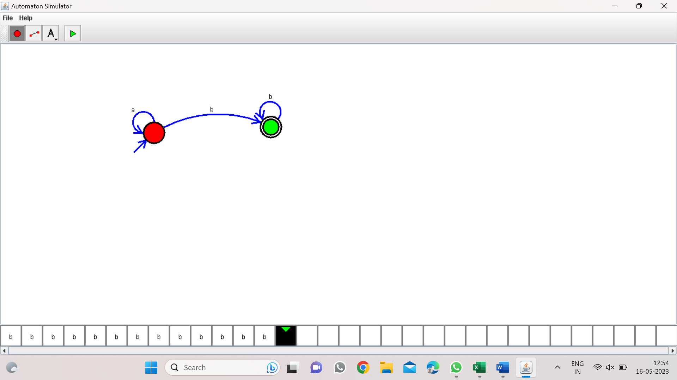*

*Result:-*

*From the above NFA diagram valid the string any no b’s*